OO Analysis and Design State Chart Diagram Exercises Solutions

Q2 Use the following diagram to Identify the following04/04/2014

1. State
2. Transition
3. Event
4. Composite
5. What Operations would be defined in Order Class?
6. What triggers the closing of an Order?

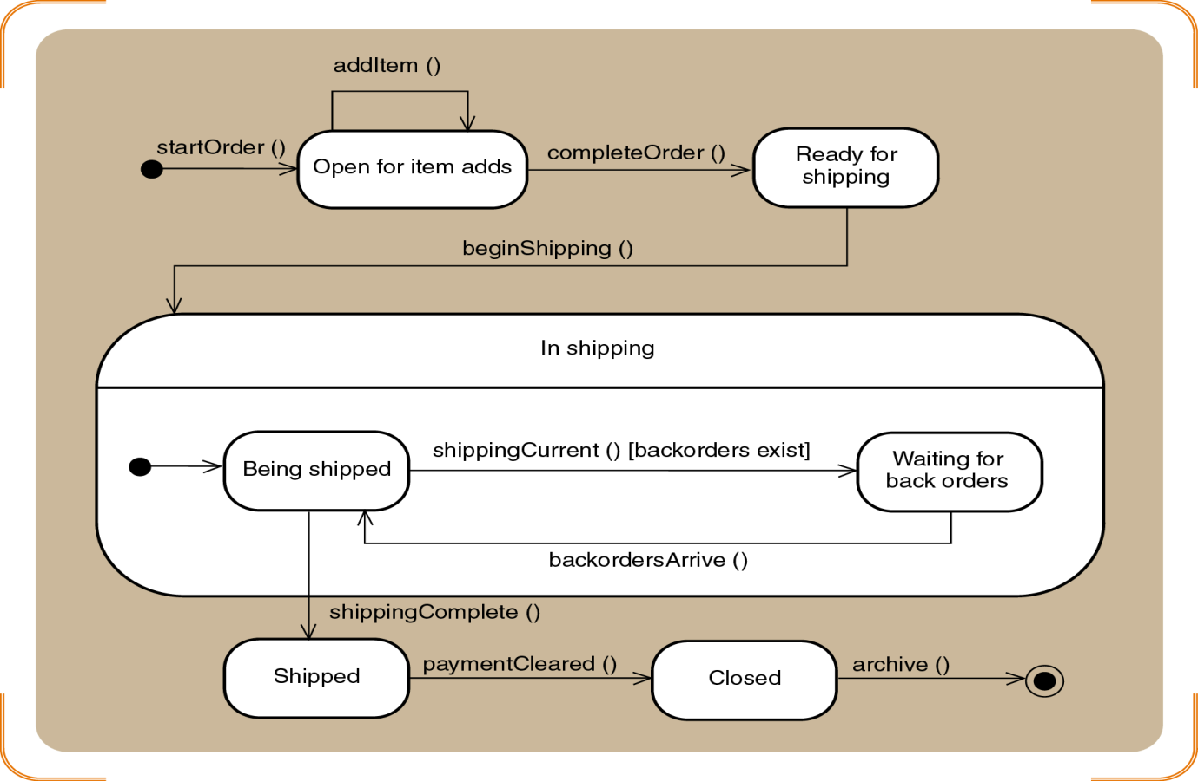

State chart Diagram for Order

Q3 Given the following description of a Certified Parcel Shipments (CPS) shipment first identify all of the states and exit transitions, then develop a state chart.

A shipment is first recognized after it has been picked up from a customer. Once it is in the system it is considered to be active and in transit. Every time it goes through a checkpoint, such as arrival at an intermediate destination, it is scanned and a record is created indicating the time and place of the checkpoint scan. The status changes when it is placed on the delivery truck. It is still active, but now it is also considered to have a status of delivery pending. Of course, once it is delivered the status changes again.

From time to time, a shipment has a destination that is outside of the area serviced by CPS. In those cases, CPS has working relationships with other couriers. Once a package is handed off to another courier, it is noted as being handed over. In those instances, a tracking number for the new courier is recorded (if it is provided). CPS also asks the new courier to provide a status change notice once the package has been delivered.

Unfortunately, from time to time a package gets lost. In those cases, it remains in an active state for two weeks, but is also marked as misplaced. If after two weeks it has not been found, it is considered lost. At that point the customer can initiate lost procedures to recover any damages.

